/\* Ashok

Report Manager and Automation Lab

6.11.19 \*/

1… Uploaded Reports and DATA source in report server web portal

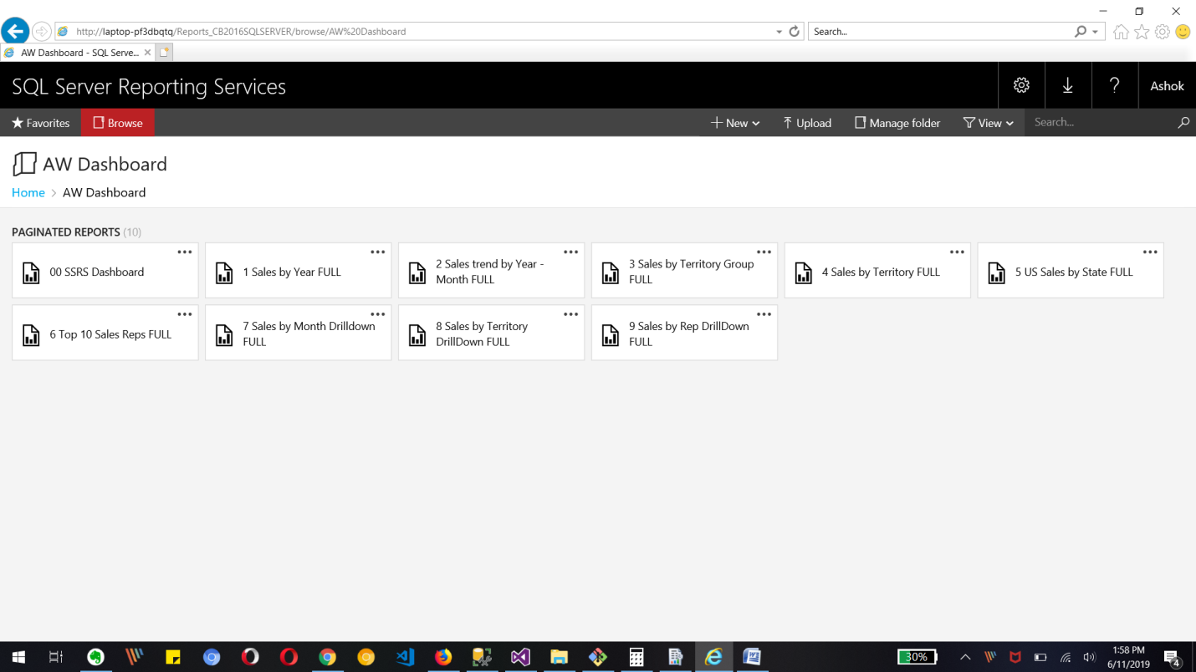

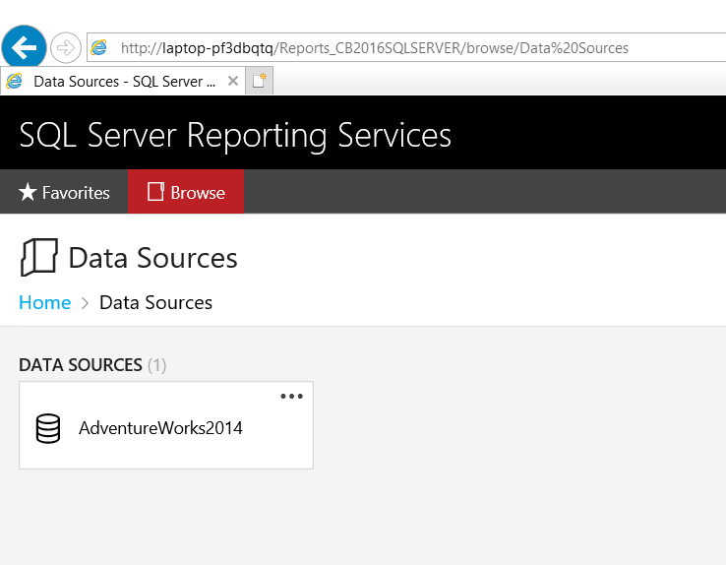

All 10 reports with parameters

1..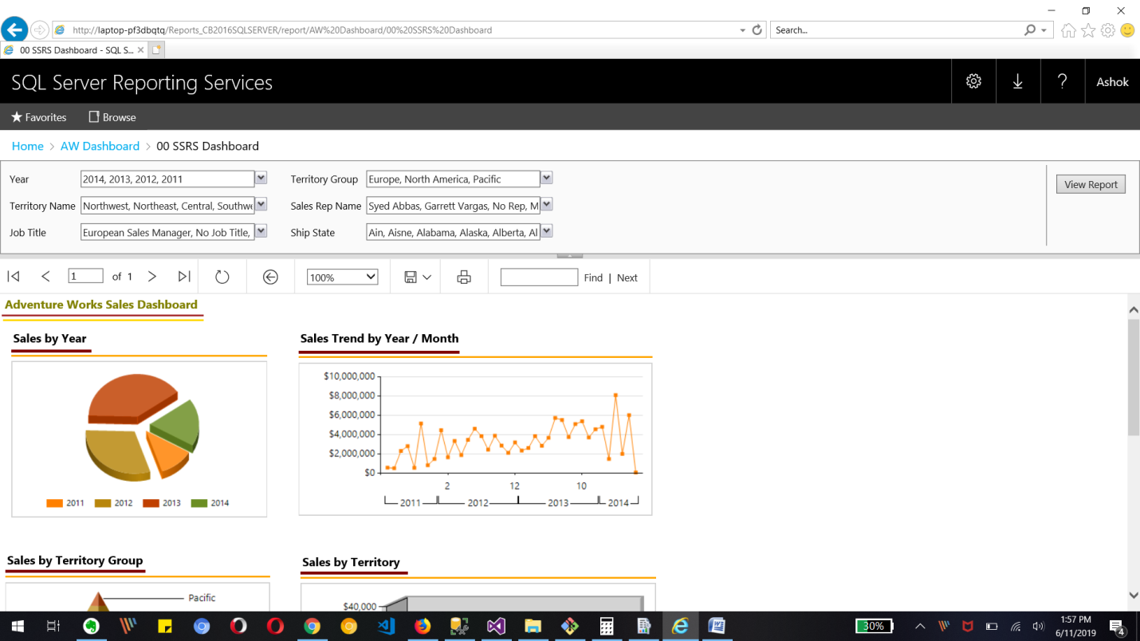

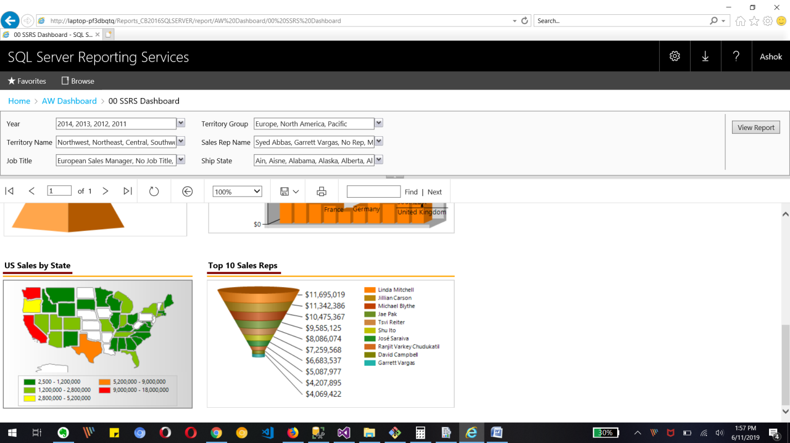

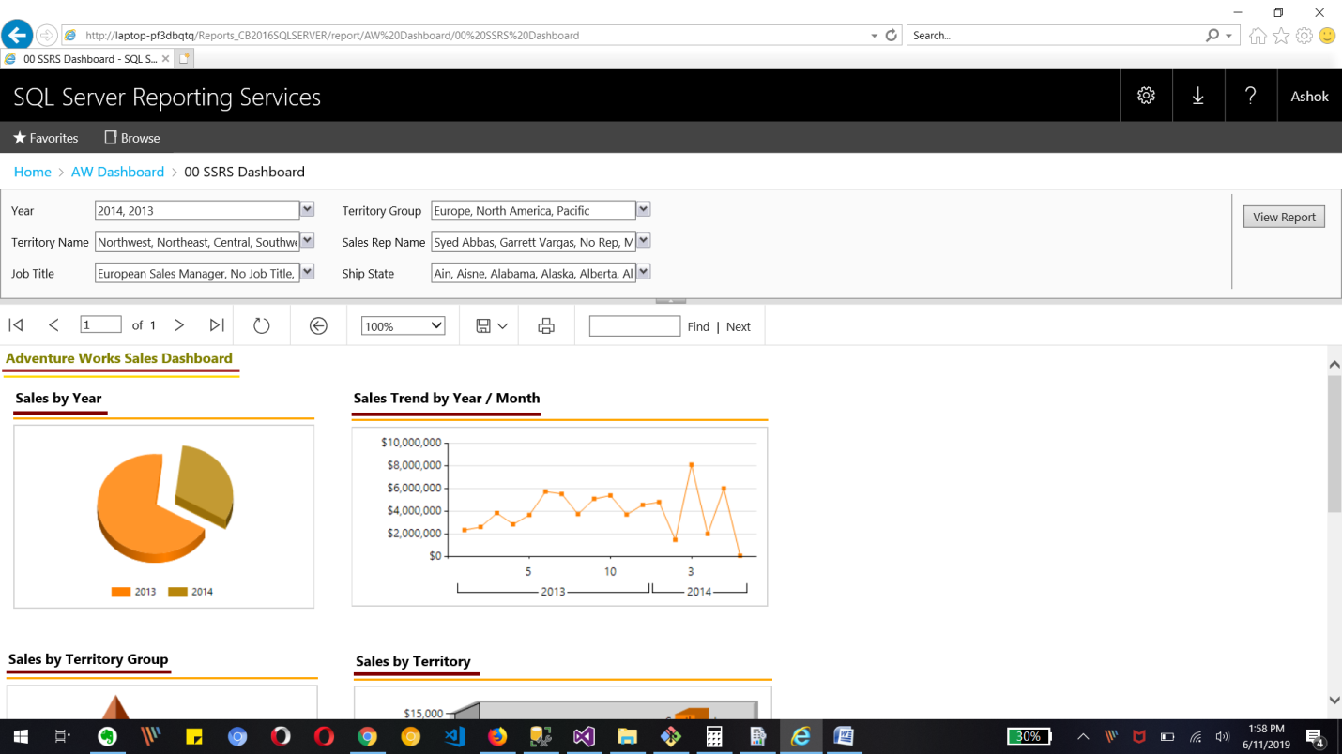

Change in Year parameter value which will change the report data as shown in image

2..Sales by year chart with Years 2012 and 2013 in web portal services

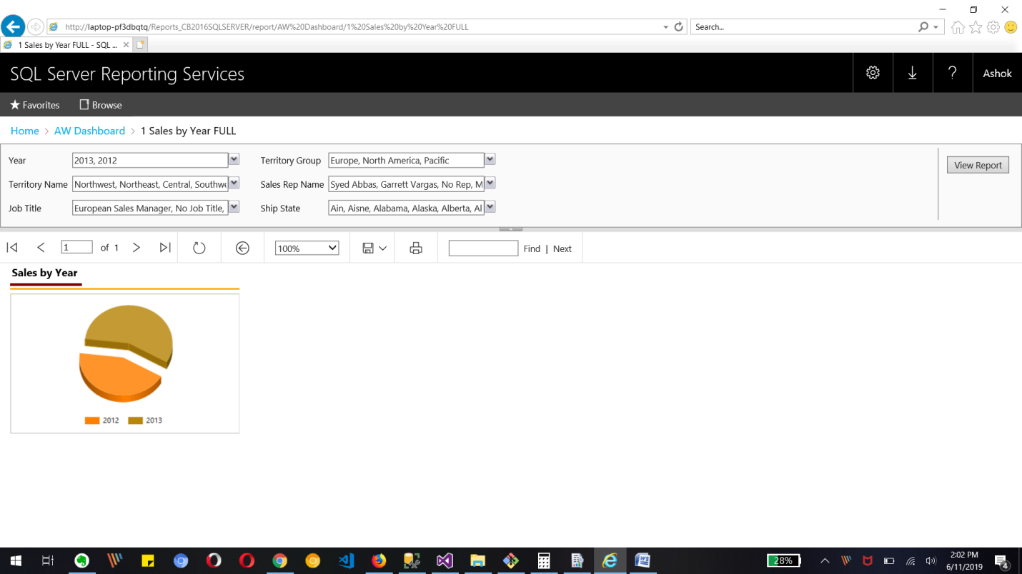

3.. Sales trend by year/Month chart with only Territory Group Europe in web portal

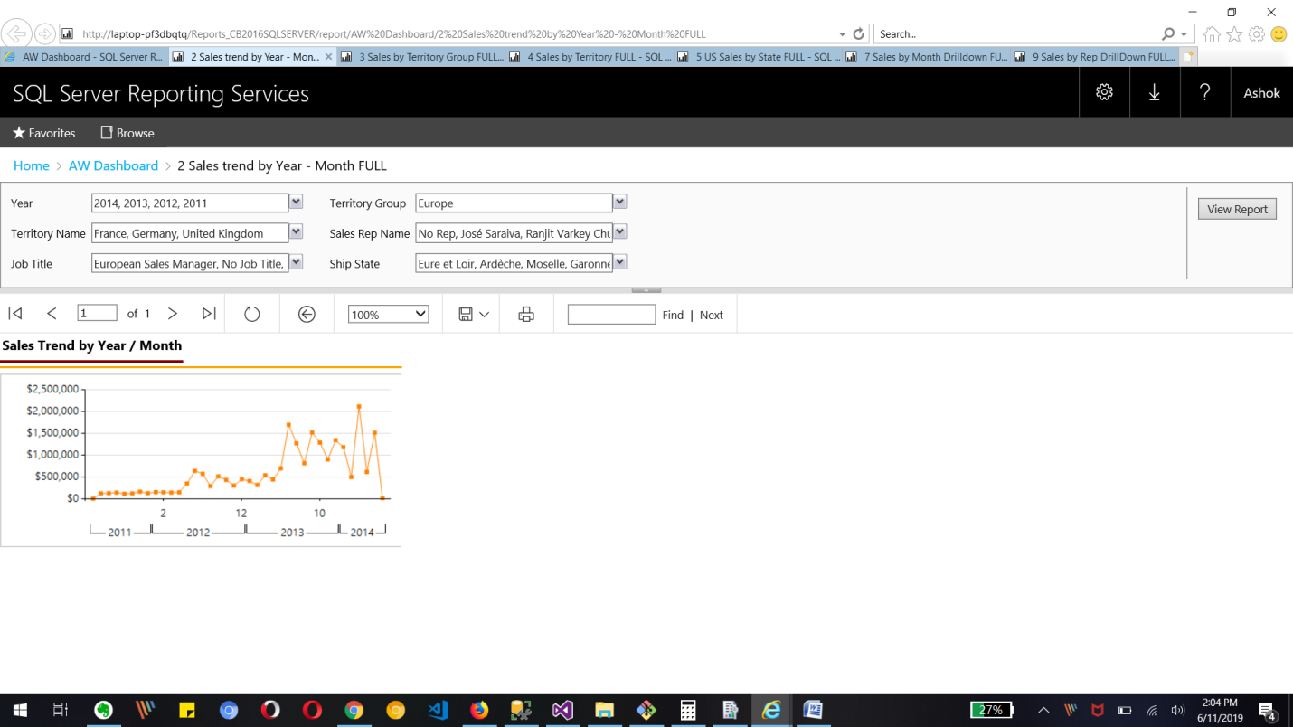

4..Sales by Territory Group for Year parameter as 2011,2012 and 2013 in SSRS web portal

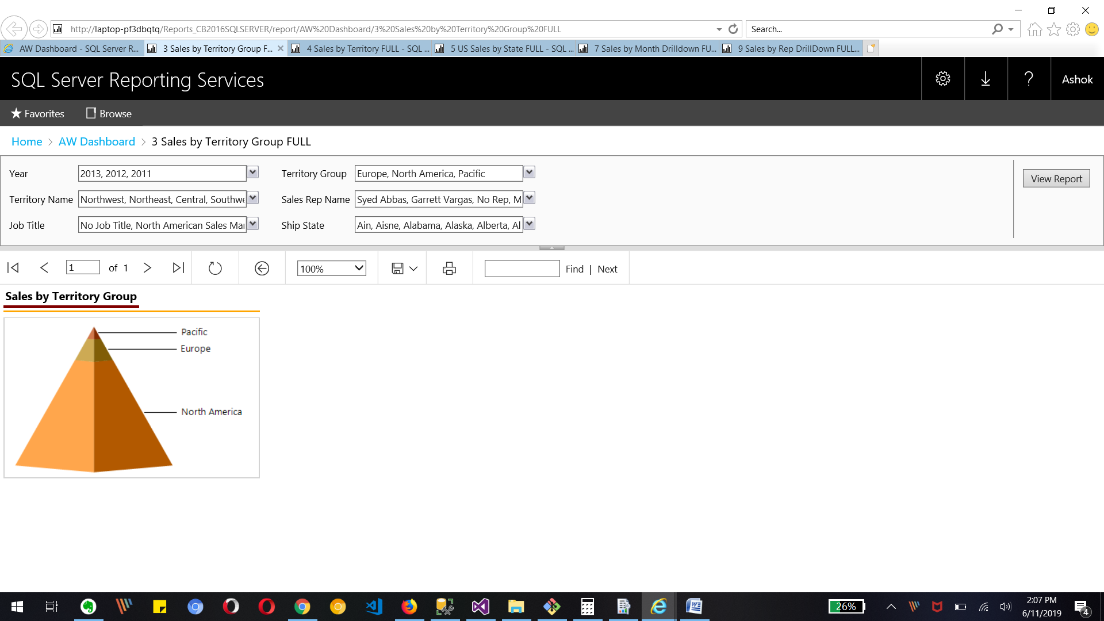

5.. Sales by Territory for Parameter Territory Group Europe in SSRS web portal

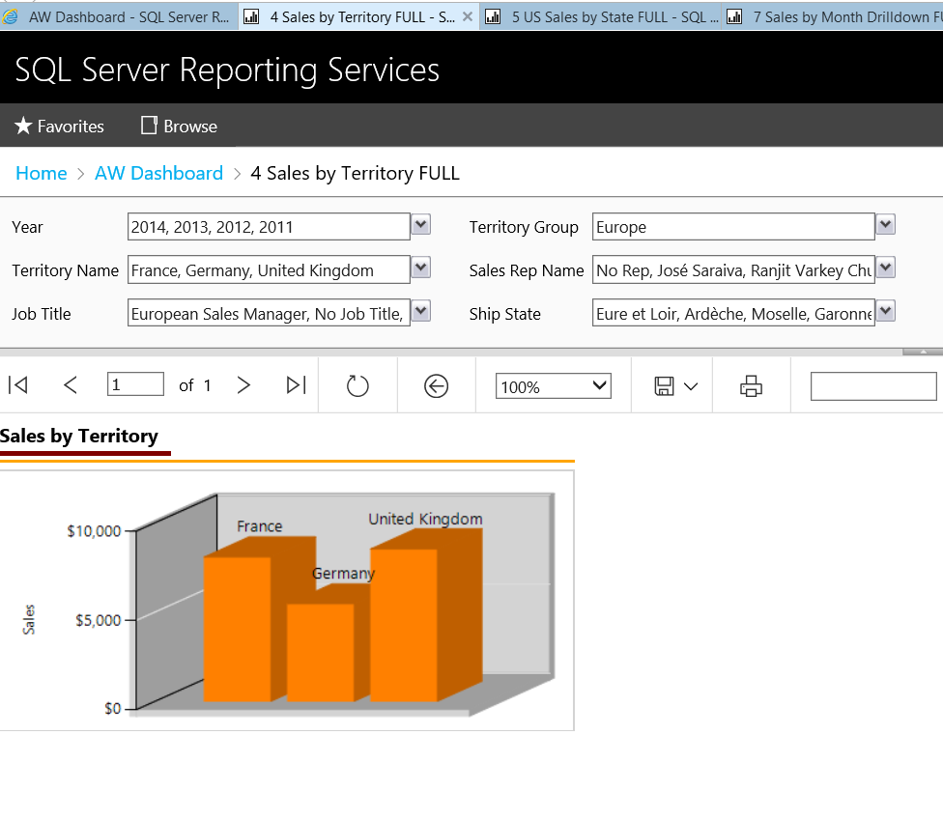

6.. US sales by State for parameter year 2012 report in SSRS web portal

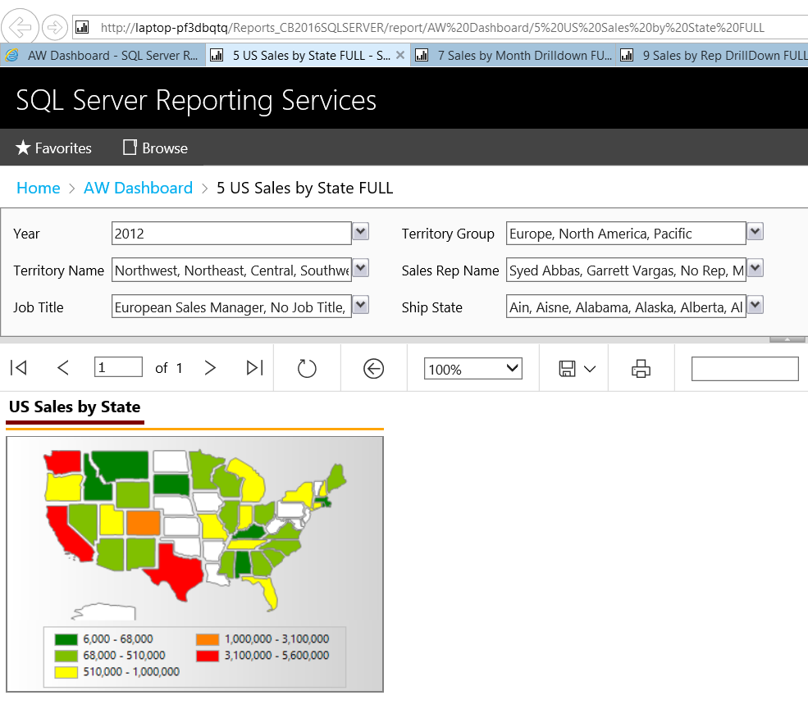

7.. Top 10 sales Rep for Pacific Territory Group Parameter report in SSRS web portal

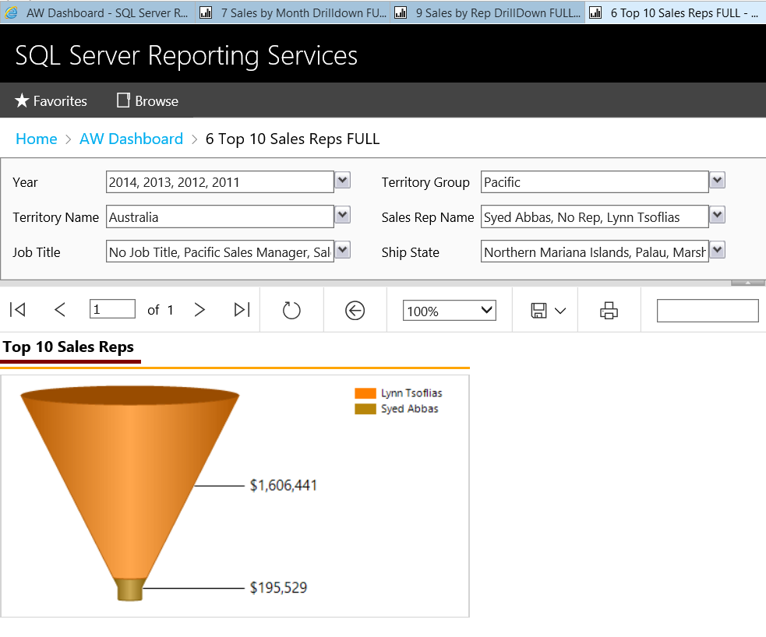

8..Sales by Month drilldown with its parameters in SSRS web portal

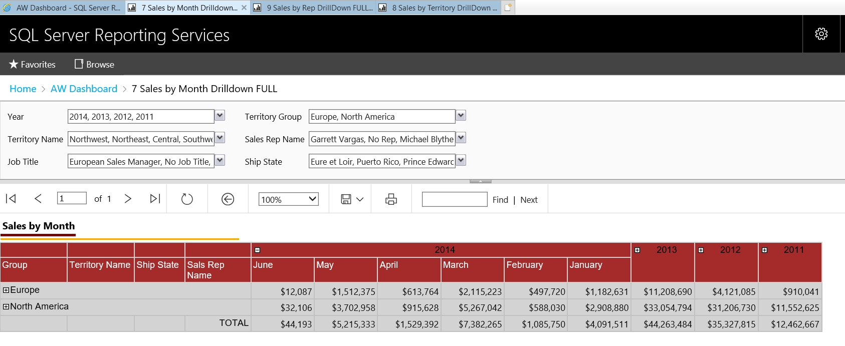

9.. Sales by Territory drilldown with its parameters in SSRS web portal

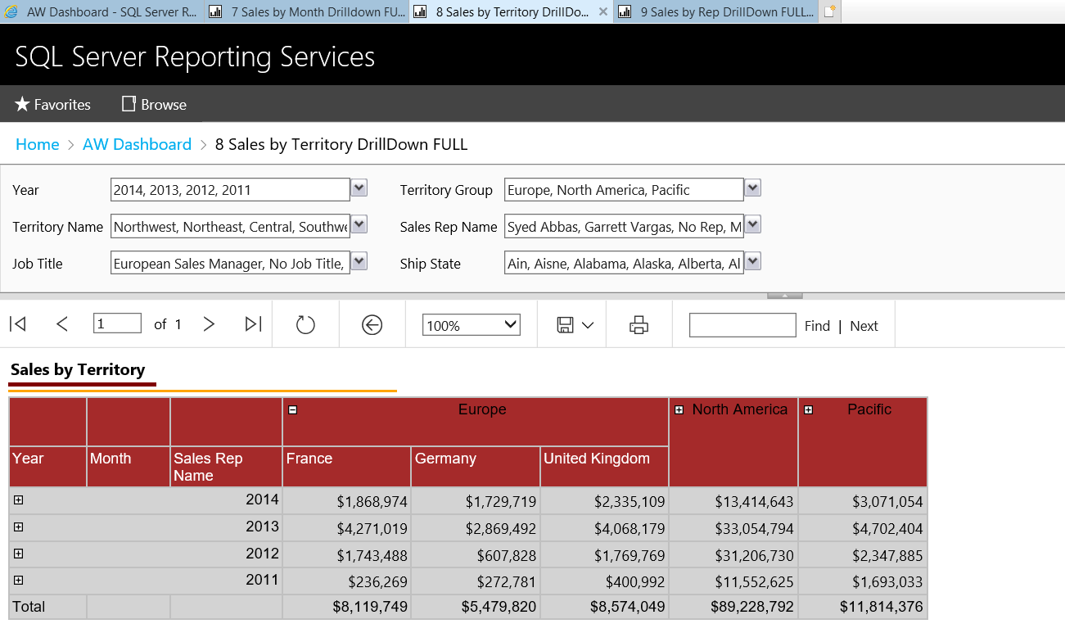

10.. Sales by Rep drilldown with its parameters in SSRS web portal

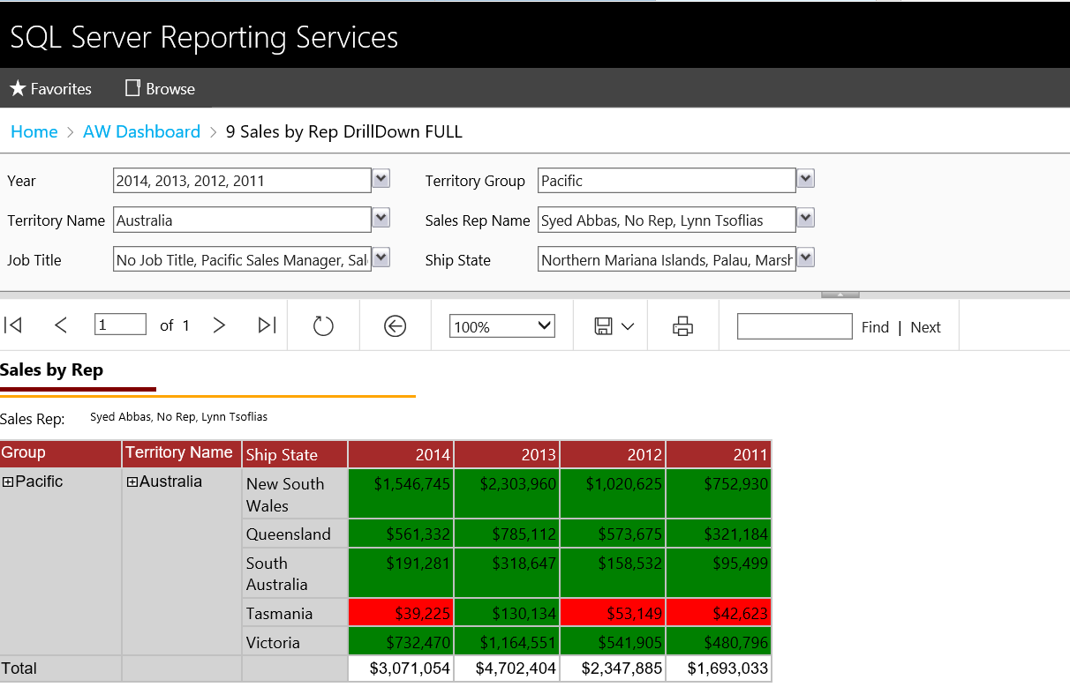

Bonus Tasks

1. Manual Snapshots of the report

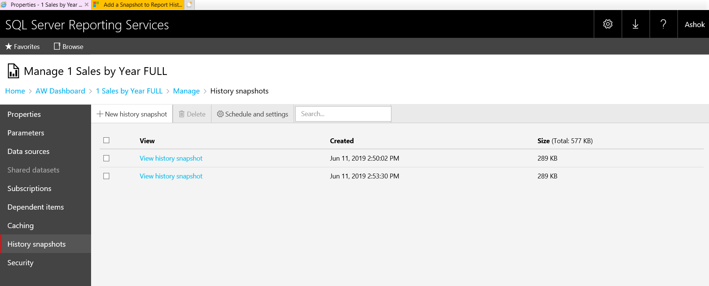

2..Create Subscription

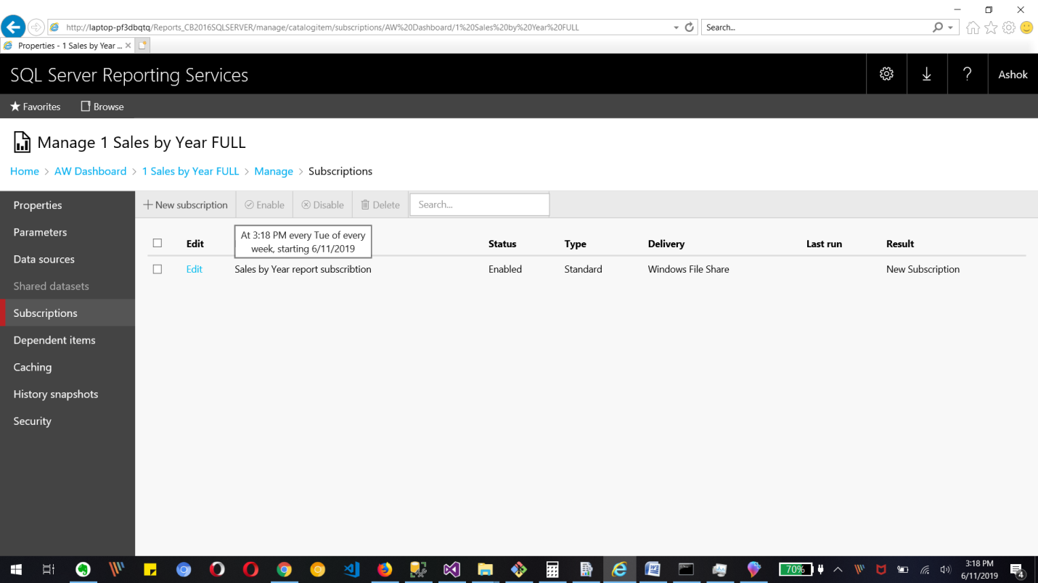

And Created PDf file at that timestamp.

